# Facial Expression Classfication App - Rui Li

2019/8/14

Under Instruction of Professor Manuel Arriaga

*Before the start our course, I had experience programming in languages including: (Python, Java, R, C, JavaScript, etc.) and had defined/written my own functions or methods and also defined my own classes or objects*

### Objective

To develop a program that can detect facial expression and link it to emotion. I think this is very useful for emotion recognition.

### Application: Emotion classifier

(1) input: a picture of expression

(2) output: the prediction of the emotion

(3) model: a pretrained model (training process in the next part)

Example picture:

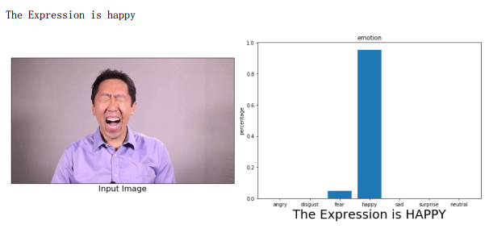

### Training Process:

I use the sequential model from the python package keras for the training process (the batch normalization, convolution, pooling, activation etc.). The model can be seen in the “model.png”.

### Some takeaway and comments:

1. After using GPU, the speed increases enormously. (Comparison in “after using gpu.png” and “Training Process using cpu.png”, which is 25 minutes versus 7.2 hours.)
2. From the plot: model accuracy during epochs, there seems to be a problem of high variance. Getting more training data is likely to help.
3. The process of training the model and building an application out of it is fascinating and I learned a lot.